Monday 2nd July 2018
19:00 – 22:00
Kinmel Hotel, Abergele

A G E N D A

Agenda Item | Person Responsible | Attachments/  Supporting Papers
- Welcome and Apologies | MH
For Discussion

2.1 Welsh GDS pilot scheme - Update | JW
2.2 LDC – reform and procedure – holding the local health board to account. Voting on issues. Should we meet in advance of the GDP/PC meeting and the OHSG to vote on agenda items? | JW
2.3 HCIW inspections - UPDATE | MH/RB
2.4 Self- Employed status of Associates, current views | RB | 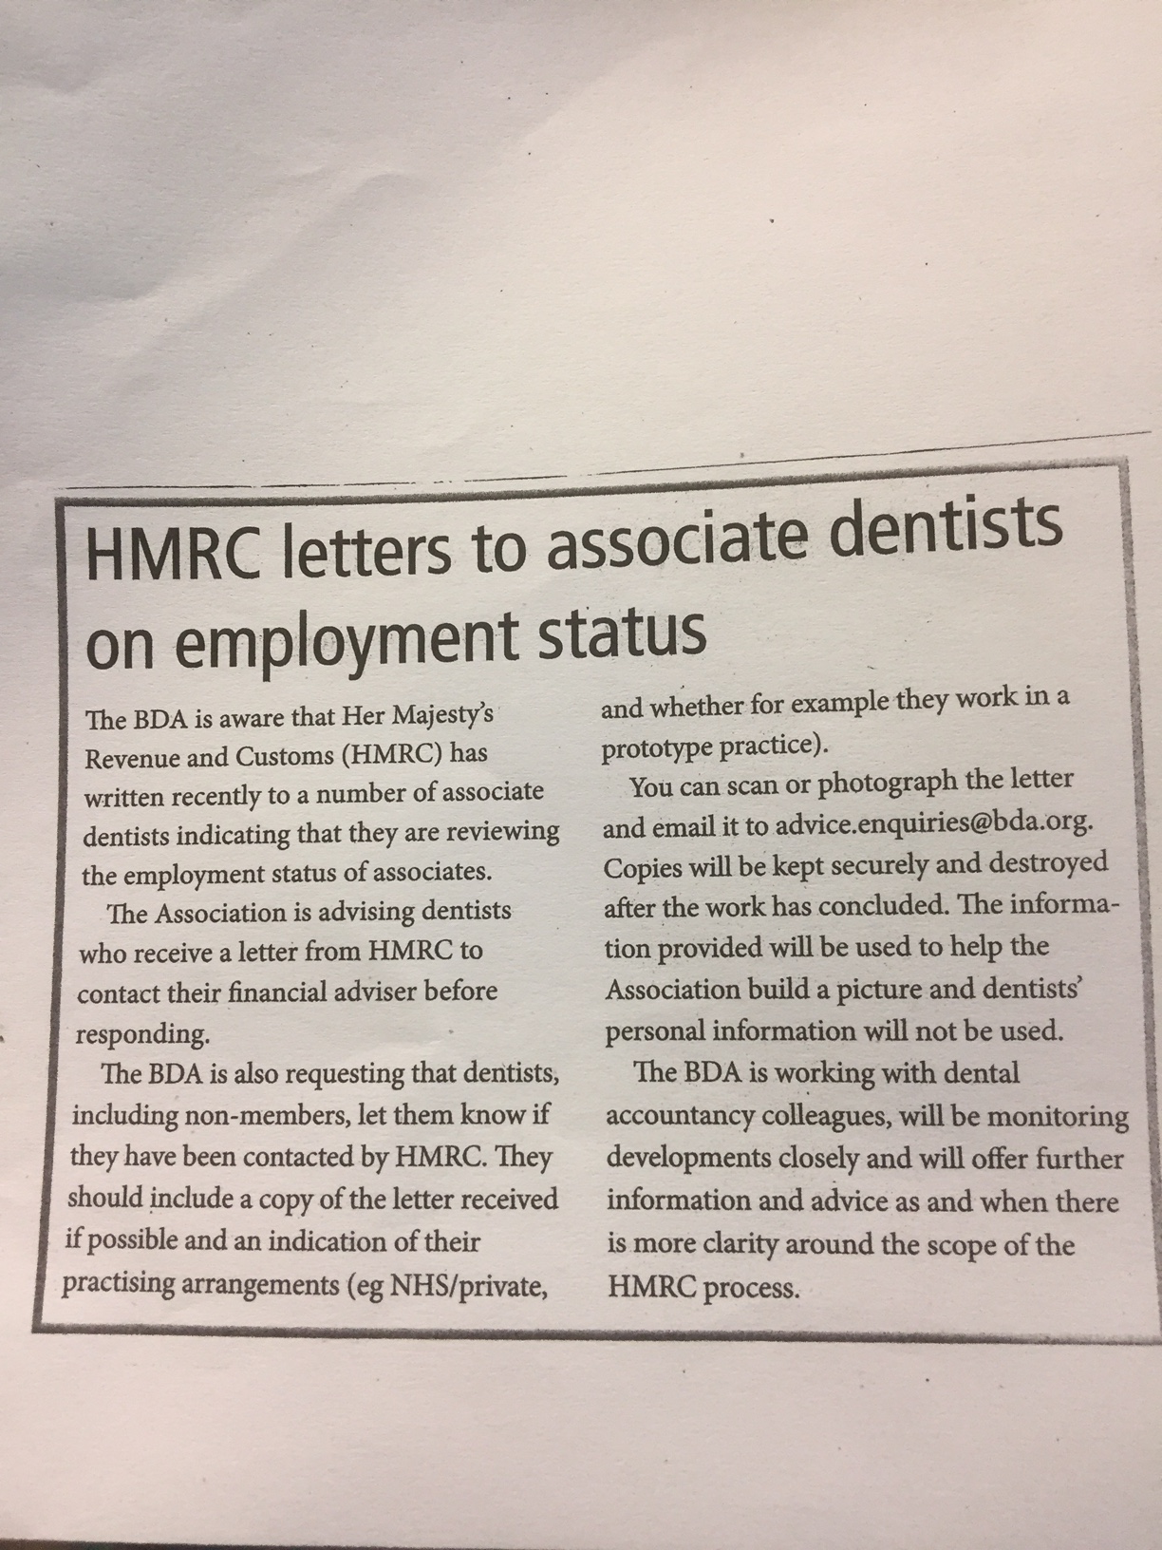
For Information

3.1 Dental Services Commissioning – update | MH
3.2 All things ortho! | BL/DP/SG
3.3 LDC Conference 2018 – Belfast. What is it all about? | JW
3.4 Welsh GDPC and explanation of its role | JW
3.5 Educational evening at Glan Clwyd 12/6/2018 | DN
3.6 All things Community and Dental health in North Wales | SS
3.7 The restorative conundrum | MH
Previous Minutes

4. Minutes of the meeting held on 9th April  2018 – for accuracy | MH
Any Other Business
5. | MH
6. Chairman’s correspondence | MH
7. Secretary’s correspondence | DN | PHE is pleased to offer an educational day around water fluoridation for LPNS and would like to invite LDC representatives. It will take place on the 10th of July at the Jury’s Inn, Great Bridgewater St, Manchester, M1 5LE from 10 to 4pm  Amalgam -
8. Treasurer’s report
Date, Time and Location of Next Meeting
10th September 2018, 19:00-22:00
Kinmel hotel Abergele

