Monday 15 June 2026
19:00 – 22:00
Online, Zoom

M I N U T E S

In attendance: Sandra Sandham, Jack Moore, Jeremy Williams, Robyn Watson, Lucy Thomas, Karun Dewan, Benjamin Lewis, Mike H, Gwenllian Williams, Taha M, Anwen Hooson, Vijaya Laxmi, Andrea, Niall McCallion, Owaise, Ian Douglas, Jayakrishna Sreeram, George, Dan Naylor

Agenda Item | Person Responsible | Attachments/  Supporting Information
1.1 Welcome and Apologies | JW/JM | Mostafa Hassaan, Jon Everard, Klevin Fernando
1.2 Minutes of Previous Meeting | MS/JW/JM | Approved as accurate.
For Discussion and Matters Arising

2.1 BCUHB Academy – Education and Training Update (inc. Collaboratives / Clusters) | RW | Academy developed for education and training purposes to support general (medical) practice.  Asked by Rachael Page in Apr 2025 to develop something similar or all dental professionals across GDS / CDS.  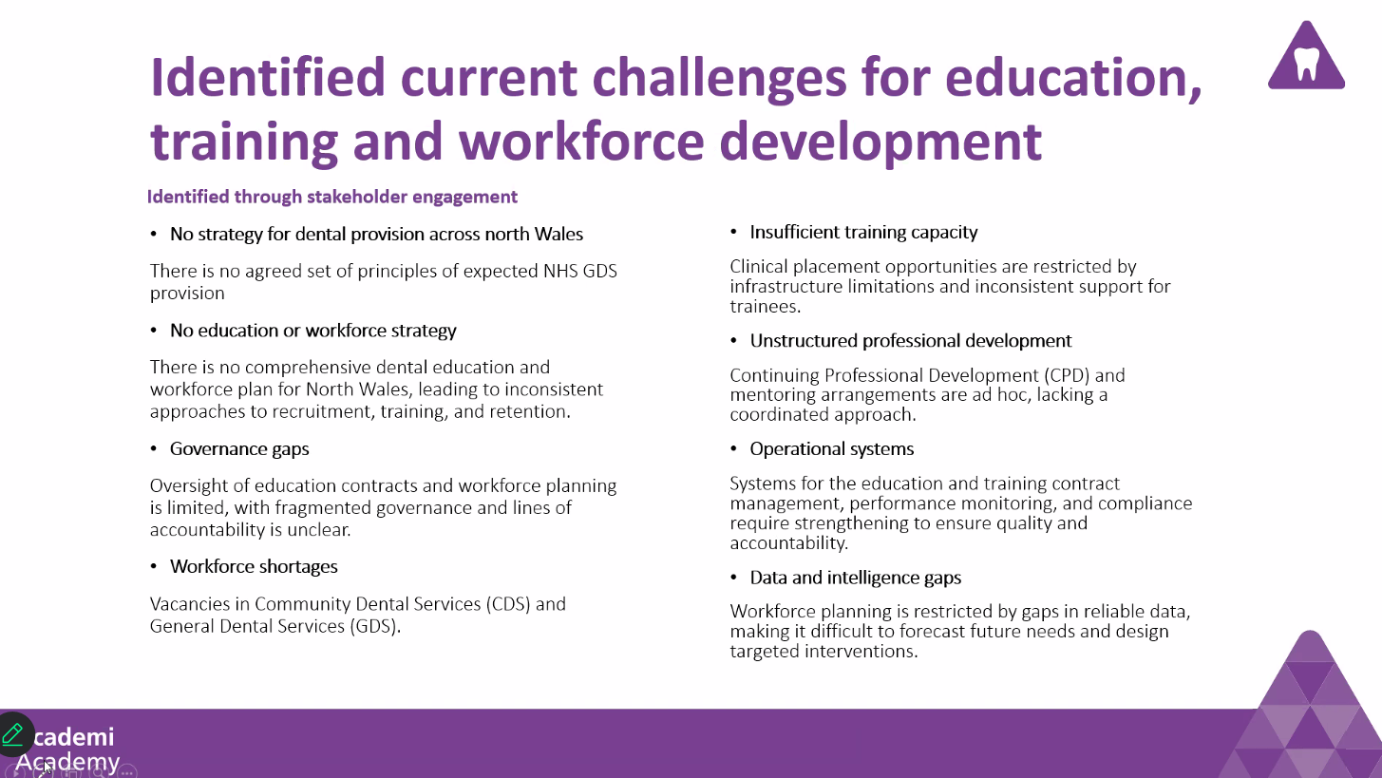  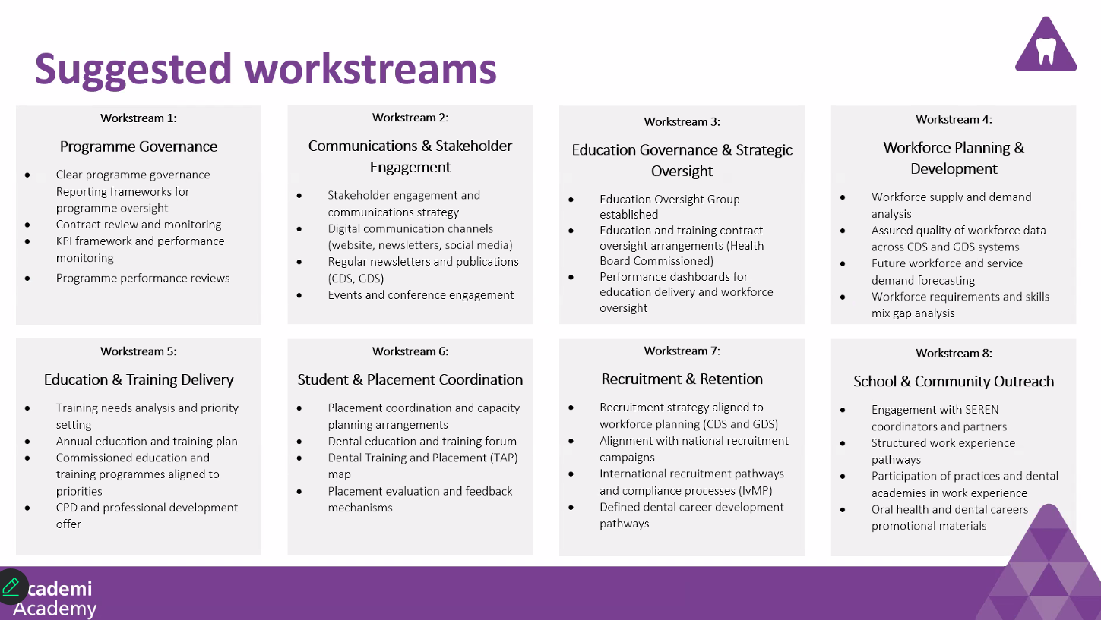  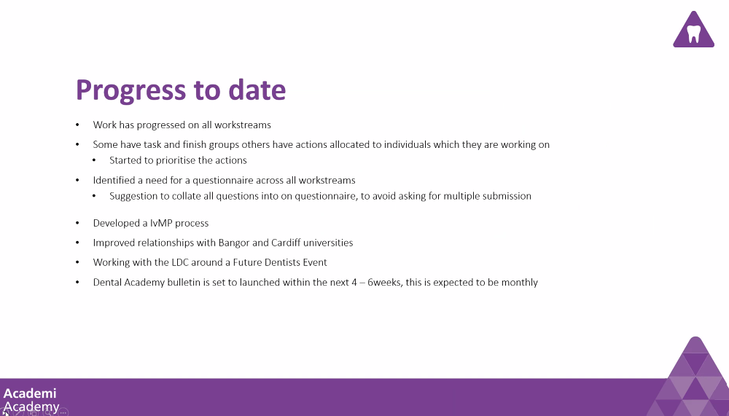  Beth Bailey is in charge of the collaboratives / clusters side of things.  Est. that workstreams need approx. 12 months to develop a robust idea of training need, submit plans in September for next year education and training plan. Took approx. 2-3 years when first started with general (medical) practice.  ID suggested ‘quick win’ would be to focus on FDS referral rejection rates and putting on targeting training to address this. The same would go for repeat referrers for more relatively ‘straightforward’ procedures. RW suggested that this was something that is being looked at. TM seconded this notion re: inappropriate referrals and upskilling. True for both NHS and private practices, who both use the FDS system.  Contact details of workstream leads included below, LDC members should feel free to reach out if they would like to get involved in a particular topic. RW will also sound out monthly update bulletin.  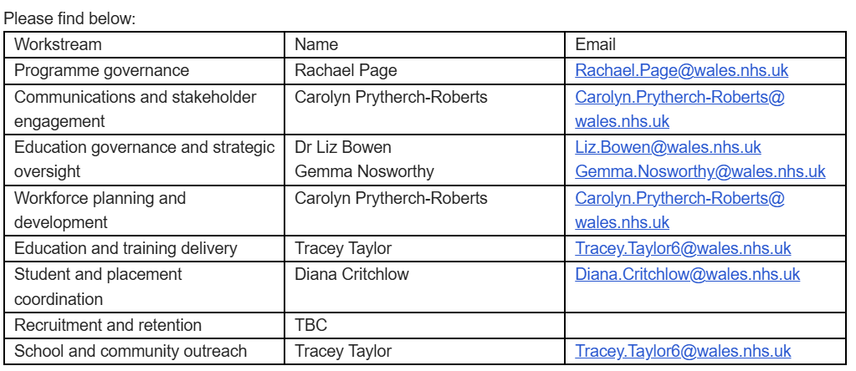  IvMP:  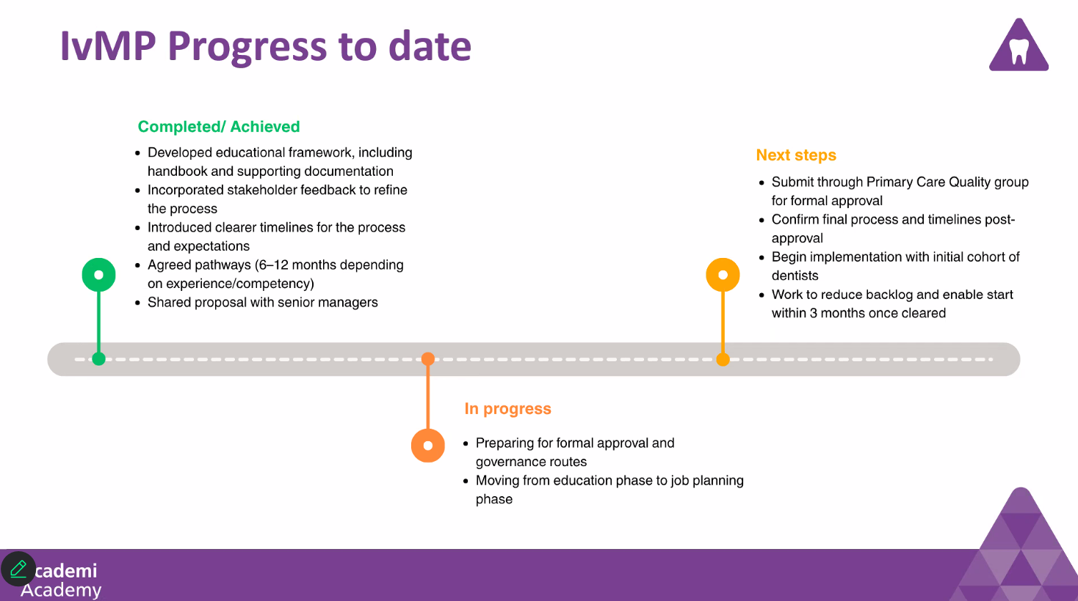  Draft document has been produced re: process, need to confirm that this can be shared more widely. Comments from LDC members have been taken into consideration, thanks to Marco and Mostafa. Suggestion also that we put RW in touch with JE who has experience in this from NW England.
2.2 Welcome to new Restorative Consultant | KD | NM / JM highlighted the expertise that already exists in N Wales; the barrier being a lack of funding for more complex restorative treatment.  JW advised that AT did do a survey (many years ago) to ascertain local expertise / knowledge in potentially helping with more  KD will feed-back to BCU – commissioning needs to appropriate and BCU needs to be serious about funding more advanced treatments.
2.3 Contractual Matters / Updates  - LDC early feedback survey | JW/JM/MS | EOY process – HB have said that they are going to adopt a similar process, but detail TBC. Letters should be out towards around 20th June – JW / MS to clarify.  As an LDC, we have only had 1x meeting with the HB since the contract landed. At the time, approx. 16,000 patients on the DAP and approx. 3,000 allocated.  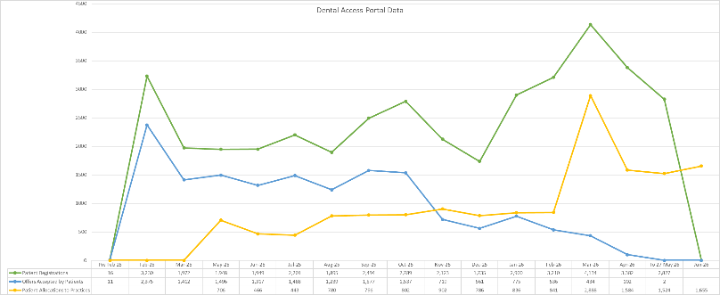  Significant underspend (just under £5mil which is significantly more than previous year).  JM presented initial feedback / results of the LDC survey.  https://docs.google.com/forms/d/e/1FAIpQLSf2Hn_Q6kCRdrEQXkcHiJmj9JcsjgqRiFBBAzdkIUBbOH0lKA/viewform?usp=header&urp=gmail_link  JW stressed that we need to stay in touch with contract managers re: claims that have been incorrectly paid, for example – they will feed-back on our behalf – let the contracting team do the legwork, only that way will they appreciate what we are dealing with day-to-day.  Practices must check schedules carefully as they are littered with errors and it is us (not BCU) that will lose out financially. Further, no NP registering on schedules at present, hoping that this will correct itself after we have 3 months of data.
2.4 Dentist and DCP Recruitment  - Vote on use of LDC website for advertising | MS/JM | Two separate issues, 1) non-endorsed catalogue of practices / practitioners that provide more advanced level care (NHS or private); 2) advertising jobs.  Do we utilise LDC funds to advertise N Wales more generally – create a narrative; ask a videographer to come in, etc.?  As a general question though, can we assume that there are no objections to flexible use of the website / LDC funds – nobody raised any concerns re: this.
2.5 LDC Matters  - Review of committee roles / personnel – questionnaire on expanding committee roles  - Meeting structure and face-to-face meetings  - Expanding on Seren programme – undergraduate ‘conference’ | JM/MS/JW | Preliminary discussions held – decision made that, given these items have come up multiple times now and little progress made, this should be the sole focus of a F2F meeting in the autumn under JM leadership.  Meeting date / location TBC – likely October.
Updates

3.1 Chair / Vice Chair / Secretary Updates  - BDA / WGDPC meeting 22nd May  - HPF  - Q&S meeting 19th May – further SDCEP update from 8th May  - LDC annual conference 4-5th June  - Additional donation – Dentists’ Health Support Trust (DHST)? | JW/JM/MS | Combined BDS Welsh Council meeting – theme of strengthening strategic leadership.  HPF – new Exec Director – seems to be very keen to understand dentistry and engage with the LDC – something for MS / JM to follow-up. ID can also offer DPA perspective.  Q&S – asked to recirculate new SDCEP guidance on prophylaxis against Infective Endocarditis for high-risk patients (released in April). Following release HEIW have hosted a well-attended training session, with more in preparation: https://ytydysgu.heiw.wales/events/05fa36c2-f044-4d57-81f8-718b9b4507f3/overview  LDC annual conference – conference presentations can be found here: https://www.ldcuk.org/documents/current-year?folder=Presentations Focus on upcoming contract reform in England, cautionary message from WGDPC.  No objections to including DHST in list of charities we donate to, proposed M Strother, seconded D Naylor.
3.2 Treasurer | AH | TBC
3.3 Orthodontics | BL | Discrepancy waiting times across specialist practices – taken JW comments re: unintended consequences back to contracting team.  From a secondary care viewpoint, insourcing programme to get waiting lists down just prior to the last Senedd election. Unfortunately, problems are coming out of the woodwork, 700 patients seen and 600 converted to care pathways within secondary care, which is unrealistic if patients want to be seen imminently. Clinical notes are also not necessarily recording all of the salient facts.
3.4 Oral Surgery  - Primary care update  - BAOS work on Tier 2 accreditation | DAB/KF  MS | TM – audit on inappropriate referrals to be started soon. JB looking into setting up training for specific referrers through HEIW CPD events at this stage, perhaps something that BCU Academy could pick up on long-term.
3.5 Restorative | KD | Covered under item 2.2.
3.6 Dental Advisors – inc. QAVP | ID/KF | PVLE (IvMP) progressing and, credit where it’s due, BCU are the only HB we are aware of that are putting a formal process in place.  BCU management are talking about going out for a third DPA role – watch this space.
Any Other Business?
Date, Time and Location of Next Meeting
Autumn Meeting – TBC | F2F
Monday 7th December 2026 | Zoom

